Trey Sylvester—---------------------------------------------------------------------------------------------------------

| **Add a search function to search for possible recipes based on cooking appliances and food items owned.** | |
| --- | --- |
| Name | Search |
| Primary Actor | User |
| Stakeholders and Interests | * User   + wants an accurate result of what they can make with what they have * Owner   + Wants the user to have a positive experience with the app |
| Preconditions | User has logged into the app, properly entered food stuffs, allergies, expiration dates and appliances into the system |
| Success Guarantee | User is supplied with a list of recipes they can make |
| Main Success Scenario | 1. The user navigates to the search tab 2. The user presses the search button 3. The system connects to the network to pull the registrar of recipes 4. The system checks the registrar for recipes that can be made 5. The system displays the search results |
| Extensions | 3a. The system cannot connect to the network  a. The system returns an error  4a. The system cannot find recipes that can be made  a. An error is shown about the lack of recipes  4b. At least 1 meal has been eaten, and the user lacks a certain dietary need  a. The system should check the resulting list of available recipes for those that meet that need  b. The system should compound items that meet the need into a separate list  c. The system should display the separate list ahead of the remaining items, with the section being labeled dietary suggestions |
| Special Requirements | 1. Recipe information should be easily readable by the user from up to a foot away 2. Search function should be easily found from the home screen 3. The search function should operate in under 5 seconds |
| Variations | Recipe app should be website based, making technological |
| Frequency of Occurrence | Extremely Common |

| **Add a function to sort resulting recipes by calorie count, portion size, cook time, difficulty of cooking, as well as setting priority ingredients** | |
| --- | --- |
| Name | Sorting |
| Primary Actor | User |
| Stakeholders and Interests | * User   + wants an accurate result of what they can make with what they have * Owner   + Wants the user to have a positive experience with the app |
| Preconditions | User has logged into the app, properly entered food stuffs, allergies, expiration dates and appliances into the system and performed a successful search |
| Success Guarantee | The system re-displays the list of recipes in order of selected search option |
| Main Success Scenario | 1. The user selects the sort button 2. The system should display the sort options popularity, calorie count, portion size, cook time, difficulty, favorites, or setting a priority ingredient 3. The user selects one of the options 4. The system should then sort the current list of recipes by that option 5. The system displays the newly sorted list |
| Extensions | 3a. The user selects priority ingredient  a. The system displays a new prompt with a list of current food stuffs  b. The user selects the desired ingredient  c. The system sorts the current list of recipes based on what has the ingredient and what doesn't  d. The system displays the newly sorted list |
| Special Requirements | 1. Sort options should be easily readable from up to a foot away 2. Sort function should operate in under a second 3. Sort button should be easily found in the search screen |
| Variations | Recipe app should be website based, making technological changes largely irrelevant if proper HTML rules are followed |
| Frequency of Occurrence | Fairly common |

| **Add function for a user to favorite recipes to view them at any time, as well as sort for when searching for recipes** | |
| --- | --- |
| Name | Sorting |
| Primary Actor | User |
| Stakeholders and Interests | * User   + wants an accurate result of what they can make with what they have * Owner   + Wants the user to have a positive experience with the app |
| Preconditions | User has logged into the app, properly entered food stuffs, allergies, expiration dates and appliances into the system and has selected a recipe |
| Success Guarantee | he recipe is favorited, and the system saves that favorited recipe to a list |
| Main Success Scenario | 1. The user selects the favorite button on the recipe 2. The system saves the recipe to a list corresponding to the user's favorited items |
| Extensions | 2a. The item was already favorited  a. The item is instead removed from the favorited items list |
| Special Requirements | 1. Button should be easily found in recipe screen |
| Variations | Recipe app should be website based, making technological changes largely irrelevant if proper HTML rules are followed |
| Frequency of Occurrence | Common |

| **Add a way for users to rate recipes so the system can later sort by rating** | |
| --- | --- |
| Name | Sorting |
| Primary Actor | User |
| Stakeholders and Interests | * User   + wants an accurate result of what they can make with what they have * Owner   + Wants the user to have a positive experience with the app |
| Preconditions | User has logged into the app, properly entered food stuffs, allergies, expiration dates and appliances into the system and has selected a recipe |
| Success Guarantee | The user rated the recipe x/5 and such data is saved on the server |
| Main Success Scenario | 1. The user selects the rate button 2. A new window is made asking for a x/5 stars rating 3. The user selects an option 4. The system connects to the network 5. The system uploads the rating to the server, updating the recipes rating with the new information |
| Extensions | 3a. The user already reviewed the item  a. The system connects to the network  b. The system uploads the rating to the server, updating the recipes rating with the new information and removing the impact the old rating had on its score  4a. The system cannot reach the internet  a. An error is shown explaining the loss of connection |
| Special Requirements | 1. Rate button should be easily found in recipe screen |
| Variations | Recipe app should be website based, making technological changes largely irrelevant if proper HTML rules are followed |
| Frequency of Occurrence | Common |

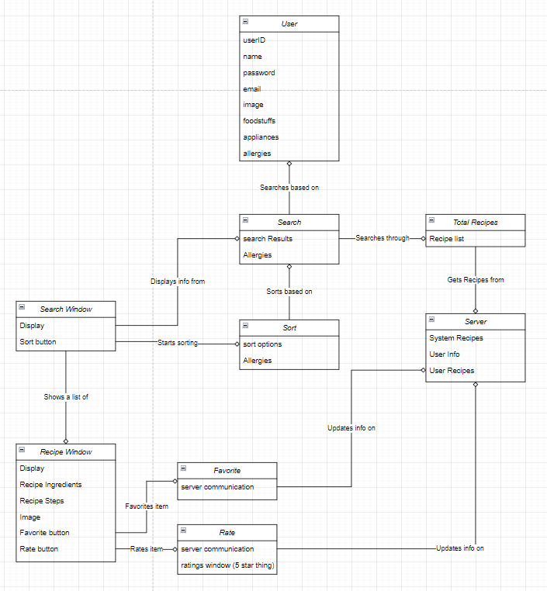

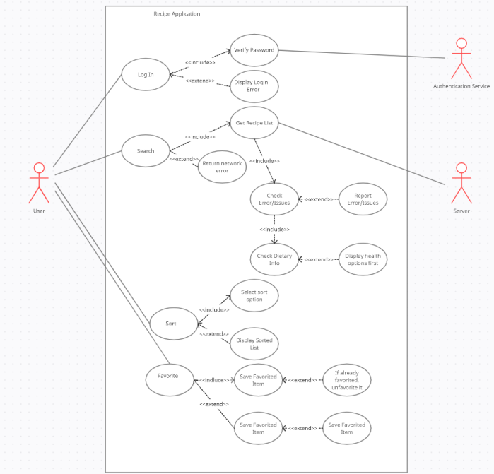

Andrew Sunwoo—------------------------------------------------------------------------------------------------------

| **Add a function to rate people’s reviews to make them more reliable** | |
| --- | --- |
| Name | Rating |
| Primary Actor | User |
| Stakeholders and Interests | * User   + wants an accurate result of what they can make with what they have |
| Preconditions | User has logged into the app and on the recipe’s rate page |
| Success guarantee | User successfully added the rate on the reviews |
| Main Success Scenario | 1. The system displays all the reviews that other people wrote 2. The user clicks a specific review they want to read 3. The system calls that review and displays on screen 4. The user clicks the rating button and rates the review 5. The system uploads the rating to the server, updates the review rating with the new information 6. The system displays a new rating on the review |
| Extensions | 4a. The user already rated the review   1. The system asks users if they want to edit the rate   2a. The user clicks Yes   * 1. The user clicks the rating button and rates the review   2. The system uploads the rating to the server, updates the review rating with the new information   3. The system displays a new rating on the review   2b. The user clicks Canel   1. The system goes back to the review page   5a. The app lost a connection with system   1. An error message shows up to inform the user |
| Special Requirements | Rate button should be easily found in a review screen. |
| Variations | Recipe app should be website based, making technological changes largely irrelevant if proper HTML rules are followed |
| Frequency of Occurrence | Common |
| Miscellaneous | N/A |

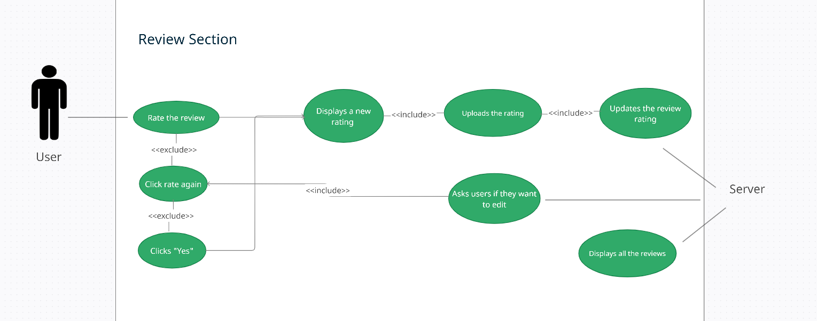

| **Add a function to comment on other people’s recipes to offer suggestions, reviews more in-depth with a star-based rating, and a way to flag recipes as fake or for other issues** | |
| --- | --- |
| Name | Commenting |
| Primary Actor | User |
| Stakeholders and Interests | * User   + wants an accurate result of what they can make with what they have |
| Preconditions | User has logged into the app and on other people’s recipes page |
| Success guarantee | User successfully commented on the recipe |
| Main Success Scenario | 1. The user scrolls down to comment section 2. The system displays the input components where users can comment on. 3. The user clicks the input components and writes the comments 4. The user clicks the submit button 5. The system uploads the comments to the database and displays the user’s comments on top of the rest of the comments |
| Extensions | 4a. The user clicks the cancel button   1. The system displays “Are you sure” alerts   2a. The user clicks “Yes”   1. The system deletes the input that was written and displays empty input component   2b. The user clicks “Cancel”   1. The system displays the input that the user was writing 2. The user clicks the submit button 3. The system uploads the comments to the database and displays the user’s comments on top of the rest of the comment |
| Special Requirements | Uploading comment should take less than 0.5 seconds |
| Variations | Recipe app should be website based, making technological changes largely irrelevant if proper HTML rules are followed |
| Frequency of Occurrence | Common |

| **Add a function that sends a notification to the recipe poster when someone comments on a user’s recipe** | |
| --- | --- |
| Name | Notification |
| Primary Actor | User |
| Stakeholders and Interests | * User   + Wants to get a notification when someone comments on his/her recipe * Other User   + Wants to comment on the recipe |
| Preconditions | User has logged into the app |
| Success guarantee | User gets the notification and sees the new comment |
| Main Success Scenario | 1. Other user comments on the user’s recipe 2. The system uploads the comments to the database and displays the user’s comments on top of the rest of the comments 3. The system sends out the notification to the user whether the user is online or not 4. The user clicks on the notification and goes on to the app 5. The system automatically shows the user’s recipe page and displays the new comment written |
| Extensions | 2a. User ignored the notification   1. The system sends out another notification 15 mins later 2. The user clicks on the notification and goes on to the app 3. The system automatically shows the user’s recipe page and displays the new comment written |
| Special Requirements | Users must have their notification on in order to receive the notification from the app. |
| Variations | Recipe app should be website based, making technological changes largely irrelevant if proper HTML rules are followed |
| Frequency of Occurrence | Common |

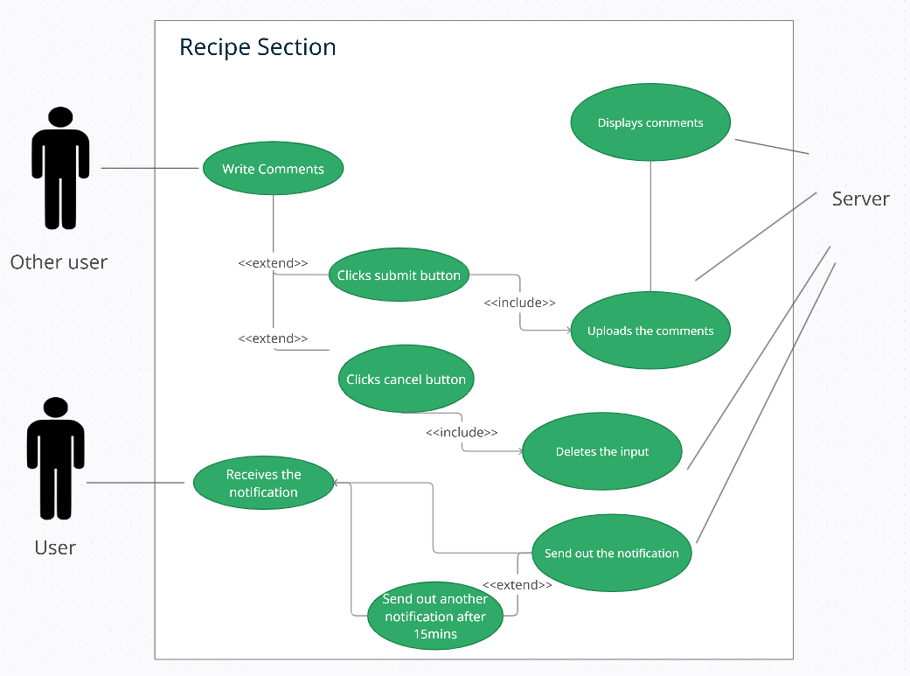

| **Add a way for users to display the top 10 comments to help users make better decisions** | |
| --- | --- |
| Name | Displaying |
| Primary Actor | User |
| Stakeholders and Interests | * User   + wants an accurate result of what they can make with what they have |
| Preconditions | User has logged into the app and on the comment section |
| Success guarantee | Top 10 comments were successfully displayed |
| Main Success Scenario | 1. The system displays the top 10 comments based on the star rating system on screen 2. The user scrolls the screen to see the comments 3. The user clicks the “more comments” button to see more comments 4. The system loads the rest of the comments on the screen |
| Extensions | 3a. There are no more comments   1. The system displays “there are no more comments” on the screen |
| Special Requirements | The comments should load less than 0.5 seconds. |
| Variations | Recipe app should be website based, making technological changes largely irrelevant if proper HTML rules are followed |
| Frequency of Occurrence | Common |

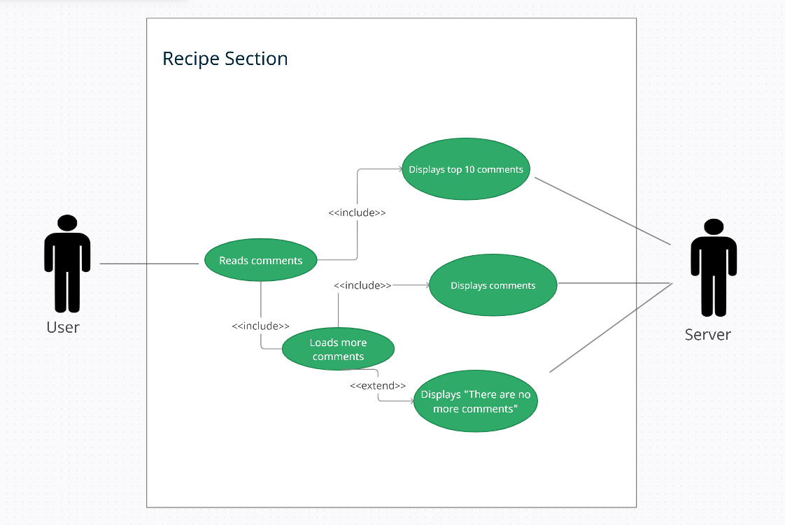

| **Add a way for users to choose a recipe they don’t like and not be suggested any recipe from that recipe owner** | |
| --- | --- |
| Name | Displaying |
| Primary Actor | User |
| Stakeholders and Interests | * User   + wants an accurate result of what they can make with what they have |
| Preconditions | User has logged into the app and on the recipe page |
| Success guarantee | User doesn’t see that recipe and any recipes from that recipe owner anymore |
| Main Success Scenario | 1. The user clicks the “do not recommend this recipe” button on the top left of screen 2. The system records the recipe and the recipe owner that the user disliked 3. The system deletes any recipe from that recipe owner from the recommended list 4. The system displays a “Thank you for your feedback” notification on the screen |
| Extensions | 1a. The user clicks the button again to cancel the dislike   1. The system brings back all the data related to that recipe and cancels all the deletions from the recommended list 2. The system displays a “Thank you for your feedback” notification on the screen |
| Special Requirements | Every process should successfully work in 0.5 seconds |
| Variations | Recipe app should be website based, making technological changes largely irrelevant if proper HTML rules are followed |
| Frequency of Occurrence | Common |

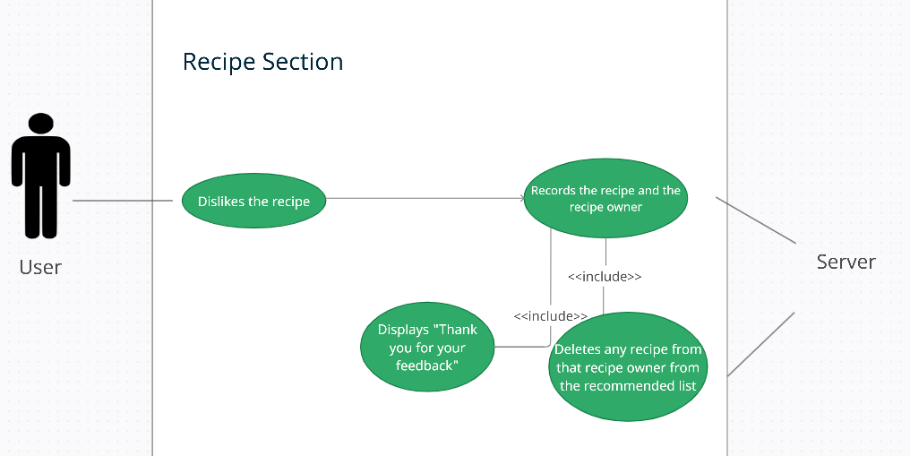

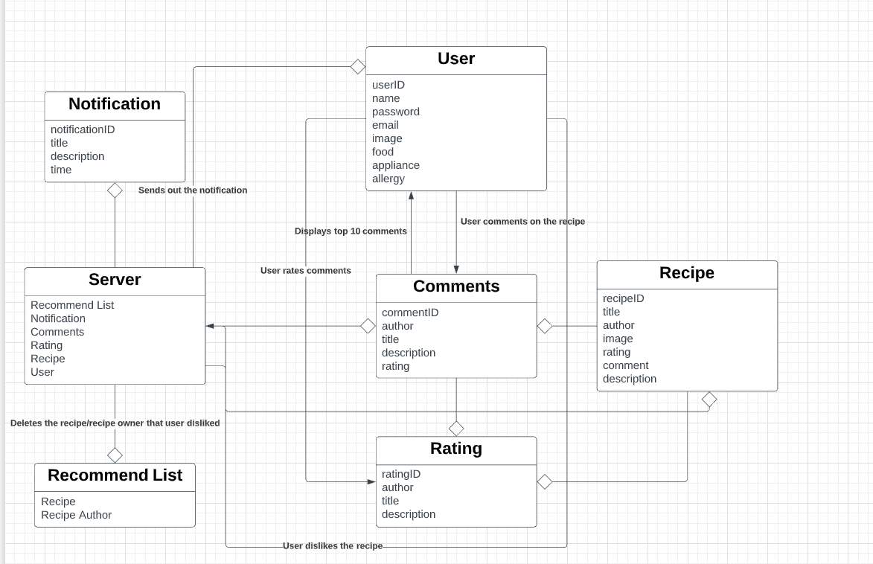

Ryan Dyke-----------------------------------------------------------------------------------------------------------------

| **Add an inventory to the application to allow the manual recording of groceries/food items** | |
| --- | --- |
| Name | Inventory |
| Primary Actor | User |
| Stakeholders and Interests | User: wants to accurately record their groceries  Owner: wants to make the experience as easy and user-friendly as possible. |
| Preconditions | User has successfully logged in and has navigated to the inventory tab. |
| Success Guarantee | The user's grocery inventory has been updated and the updated grocery inventory list is displayed for the user. |
| Main Success Scenario | 1. User presses on the section for groceries 2. User presses add item to list 3. System provides the user with an input line 4. User enters in the food item they want to add to the list and its relevant data (such as expiration date) 5. User submits their item and its data by pressing enter 6. System adds the item to their grocery inventory list 7. System returns the user to the grocery inventory list where the user can see that the item was added |
| Extensions | 4a. Invalid expiration date  1a. System prompts user that the expiration date is invalid and to enter in another date  1b. The user enters in another date and declines to enter one  Repeat steps 1 and 2 until a valid expiration date is entered or declined by user |
| Special Requirements | The system should update the grocery inventory list within 0.01 seconds of the user entering in the items information. |
| Variations | 3a. Keyboard pops up for user to enter in item if they are on mobile |
| Frequency of Occurrence | Extremely Frequent |

| **Add an inventory to the application to allow the manual recording of cooking appliances** | |
| --- | --- |
| Name | Inventory |
| Primary Actor | User |
| Stakeholders and Interests | User: wants to accurately record their appliances  Owner: wants to make the experience as easy and user-friendly as possible. |
| Preconditions | User has successfully logged in and has navigated to the inventory tab. |
| Success Guarantee | The user's appliance inventory has been updated and the updated appliance inventory list is displayed for the user. |
| Main Success Scenario | 1. User presses on the section for appliances 2. User presses add item to list 3. System provides the user with a list of appliances 4. User selects the appliance they want to add to the list 5. User submits their appliance by pressing done 6. System adds the appliance to their appliance inventory list 7. System returns the user to the appliance inventory list where the user can see that the appliance was added |
| Extensions | 4a. The user does not find the appliance they would like to add from the list  1a. The user can select to add another similar appliance (such as adding a toaster oven instead of a toaster)  1b. The user can back out and not add any appliances to their list |
| Special Requirements | The system should update the appliance inventory list within 0.01 seconds of the user entering in the appliance. |
| Variations | 3a. The user can use their finger to scroll through the list for mobile  3b. The user can use the scroll wheel on the mouse for PC |
| Frequency of Occurrence | Not too often |

| **Add a function to sort food items by metrics such as expiration date/food group** | |
| --- | --- |
| Name | Inventory |
| Primary Actor | User |
| Stakeholders and Interests | User: wants to sort their inventory list by certain metrics to find what foods they have/want to look at easier  Owner: wants to make the experience as easy and user-friendly as possible. |
| Preconditions | User has successfully logged in, navigated to the inventory tab, and selected the grocery inventory list. |
| Success Guarantee | The user can look at their sorted grocery inventory list by whatever metric option they choose. |
| Main Success Scenario | 1. User presses the sort button 2. System provides a drop down menu with multiple options to sort the list by 3. User selects an option 4. System sorts the list based on the users selected option 5. System provides a category at the bottom for unsorted foods that could not be sorted based on the selected option of the user 6. System closes the drop down menu |
| Extensions | 3a. A user does not want to select an option and wants to get out of the drop down menu  1. The user can click or tap anywhere outside of the drop down menu to exit it |
| Special Requirements | The sort menu should provide the options with big enough boxes for users to easily tap their preferred option on mobile. |
| Variations | 2. On mobile, the drop down menu takes up the bottom section of the screen like the typical apple drop down scroll menus. |
| Frequency of Occurrence | Fairly Often |

| **Add a function to warn the user of potentially expired food** | |
| --- | --- |
| Name | Inventory |
| Primary Actor | User |
| Stakeholders and Interests | User: wants to be notified when they have food that is near expired or has already expired  Owner: wants to make the experience as easy and user-friendly as possible. |
| Preconditions | User has successfully logged in. |
| Success Guarantee | The user has been notified of the near expired or expired food. |
| Main Success Scenario | 1. User selects the inventory tab 2. System pops up with a text box letting the user know they have food expiring soon and which food item is expiring soon 3. User selects the okay button after reading the text box verifying that they have read the notification 4. System will later remind again once the food is expired 5. User will be given an option to exit out of the notification or to remove the expired food from the list 6. System will exit out of the notification text box and take the user to the inventory tab page |
| Extensions | 5. User chooses to remove the expired food from the list  1. System will remove the food item from the grocery list |
| Special Requirements | 1. The notification box should have large buttons and be easy to click out of 2. If multiple food items are expired in the list at the same time then the pop up notification should include all of the expired foods |
| Frequency of Occurrence | Not too often |

| **Add in an ability to input allergies to make sure no recipes with ingredients containing those allergens get suggested** | |
| --- | --- |
| Name | Inventory |
| Primary Actor | User |
| Stakeholders and Interests | User: wants to input their allergies so that they never show up in any recipes  Owner: wants to make the experience as easy and user-friendly as possible. |
| Preconditions | User has successfully logged in and has selected the inventory tab. |
| Success Guarantee | The user entered in any allergies they have and the allergies are shown in red in their own section |
| Main Success Scenario | 1. User selects allergies section of inventory 2. User selects add allergy button 3. System presents user with a pop down menu of common allergies 4. User selects as many allergies as they need 5. User selects enter to add their allergies to the list 6. System returns user to the inventory tabs home page |
| Extensions | 3a. System does not have the allergy the user is looking for  1a. User can select option saying that their allergy is not listed  1b. System will provide a text box for the user to input their allergy  1c. User enters in their allergy and selects enter |
| Special Requirements | The system should have each pop up for entering information within 0.01 seconds. |
| Variations | 3. User should be able to select as many options as possible |
| Frequency of Occurrence | Only a few times total. So very unoften. |

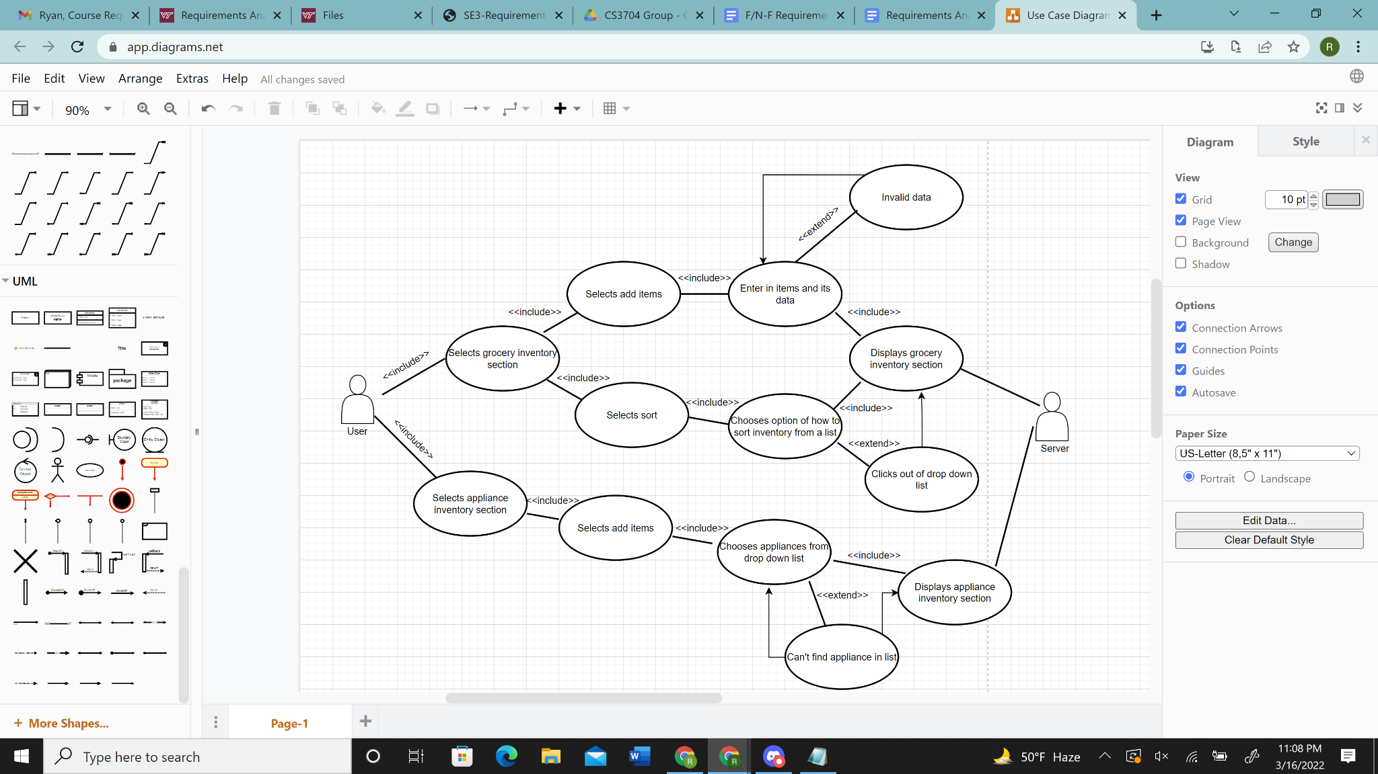

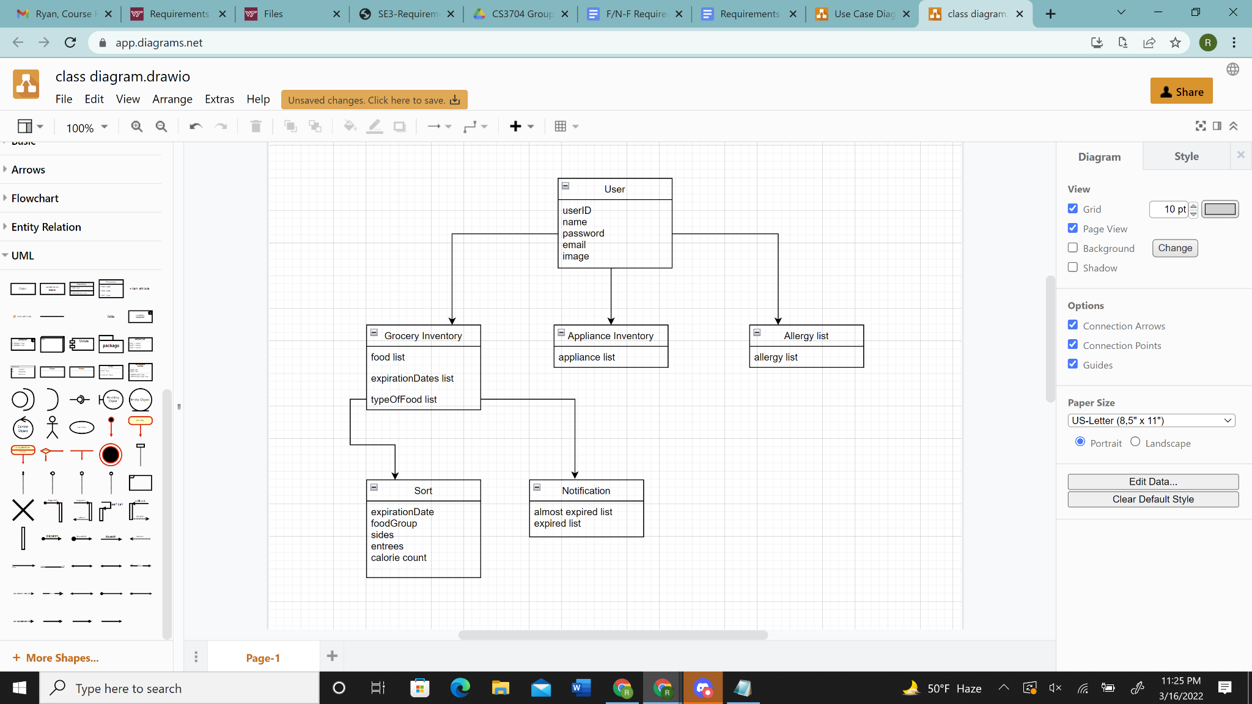

Jacob Mandelbaum —-------------------------------------------------------------------------------------------------

| **Add a way for people to post recipes for everyone that uses the app to view** | |
| --- | --- |
| Name | Post recipes |
| Primary Actor | User |
| Stakeholders and Interests | User - wants to be able to post recipes for other people to see    Owner - wants to give the user a good experience and allow them to share the recipes they want to share |
| Preconditions | The user trying to post a recipe is logged into an account |
| Success guarantee | The recipe that the user tried to post is successfully posted, and available for any other user on the app to view. |
| Main Success Scenario | 1. The user navigates to the recipes page  2. The user presses the input recipe button  3. The user fills out the ingredient list, appliance list, cook time, portion size, and difficulty of cooking, and sets the recipe visibility to public  4. The user clicks the post recipe button  5. The app automatically calculates the calorie count and fills it out  6. The recipe is successfully posted to the app and is available to be seen by everybody |
| Extensions | 6a. The recipe cannot successfully be posted to the application  1. The app reports an error saying it could not be  posted and to try again |
| Special Requirements | Recipe post page should be able to be navigated to easily  Input fields and buttons should be visible from far away |
| Variations | Recipe app should be website based, making technological changes largely irrelevant if proper HTML rules are followed |
| Frequency of Occurrence | Common |

| **Add a way for people to see what ingredients they are missing when they view a recipe** | |
| --- | --- |
| Name | Missing ingredients |
| Scope | Recipe App |
| Stakeholders and Interests | User - wants to know what ingredients they are missing when looking at a recipe  Owner - wants to give the user the information to make their experience as easy as possible |
| Preconditions | The user has an inventory of ingredients that is stored on their account or device |
| Success guarantee | The app will tell the user what ingredients they do not have in their inventory when they are looking at a recipe |
| Main Success Scenario | 1. The user navigates to the page of a recipe that they want to look at  2. The user scrolls to the ingredients list  3. The application checks the ingredients list against the user's inventory  4. The application displays whether or not each ingredient is in the user's inventory |
| Extensions | 3a. The application cannot connect to the user's inventory  1. The application would display that it does not know  whether or not an ingredient is in their inventory |
| Special Requirements | Recipe page should be navigated to easily and loaded quickly  Display of whether the ingredient is in the inventory or not should be easily visible and easy to understand |
| Variations | Recipe app should be website based, making technological changes largely irrelevant if proper HTML rules are followed |
| Frequency of Occurrence | Common |

| **Add a function to comment on recipes to offer suggestions, or reviews more in depth than a star based rating, rate people’s comments to move them up/down the list, and to flag other people recipes for issues or fake recipes** | |
| --- | --- |
| Name | Recipe feedback |
| Primary Actor | User |
| Stakeholders and Interests | User - wants to be able to provide feedback on recipes and other people's thoughts on recipes  Owner - wants to facilitate a sense of community and some community moderation of recipes and comments |
| Preconditions | The user is signed into an account |
| Success Guarantee | The user's comment, review, or rating will be posted, or the flag will be reported to the owner |
| Main Success Scenario | 1. The user navigates to a recipe's page  2. The user clicks either the comment, review, rating, or flag button  3. The user fills out their comment, review, or flag, or picks an option for rating  4. The user clicks the submit button  5. The comment, review, or rating is posted publicly to the application, and the flag is sent to the owner |
| Extensions | 5a. The comment, review, rating, or flag is not able to be posted  or reported   1. Report an error message to the user and allow them to try again |
| Special Requirements | The buttons should be easily visible and understandable |
| Variations | Recipe app should be website based, making technological changes largely irrelevant if proper HTML rules are followed |
| Frequency of Occurrence | Common |

| **Ability to show alternative ingredients for recipes, in the case that the user does not have a certain ingredient.** | |
| --- | --- |
| Name | Alternative ingredients |
| Primary Actor | User |
| Stakeholders and Interests | User - wants to have the information of what ingredients can be replaced with available to them  Owner - wants to provide information to make the user’s experience as friendly as possible |
| Preconditions | User has an inventory of ingredients |
| Success Guarantee | The application will let the user know what ingredients they can use to replace an ingredient they are missing |
| Main Success Scenario | 1. The user navigates to a recipe’s page 2. The user finds an ingredient in the recipe that they are missing 3. The user clicks on a “view replacements” option next to the ingredient 4. The application reports possible replacements for the ingredient |
| Extensions | 2a. The application cannot determine what ingredients the user has   1. The application would display that it cannot tell what ingredients the user has in their inventory |
| Special Requirements | The buttons are easily seen and understood |
| Variations | Recipe app should be website based, making technological changes largely irrelevant if proper HTML rules are followed |
| Frequency of Occurrence | Common |

| **Add a way for users to mark recipes they’re not interested in and not see them again** | |
| --- | --- |
| Name | Mark not interested |
| Primary Actor | User |
| Stakeholders and Interests | User - wants to be able to control what recipes they see  Owner - wants to give the user as many options to make their experience better as they can |
| Preconditions | User is signed in to an account |
| Success Guarantee | A recipe will be marked as one the user is not interested in, and the user will not see the recipe again |
| Main Success Scenario | 1. User navigates to the recipe page 2. User decides that they are not interested in the recipe, and clicks the not interested button 3. Application stores that the user is not interested and makes sure it is never suggested or shown |
| Extensions | 3a. Application is unable to store the information   1. Reports an error to the user that the request was unable to be processed |
| Special Requirements | The not interested button is easily visible and understandable |
| Variations | Recipe app should be website based, making technological changes largely irrelevant if proper HTML rules are followed |
| Frequency of Occurrence | Common |

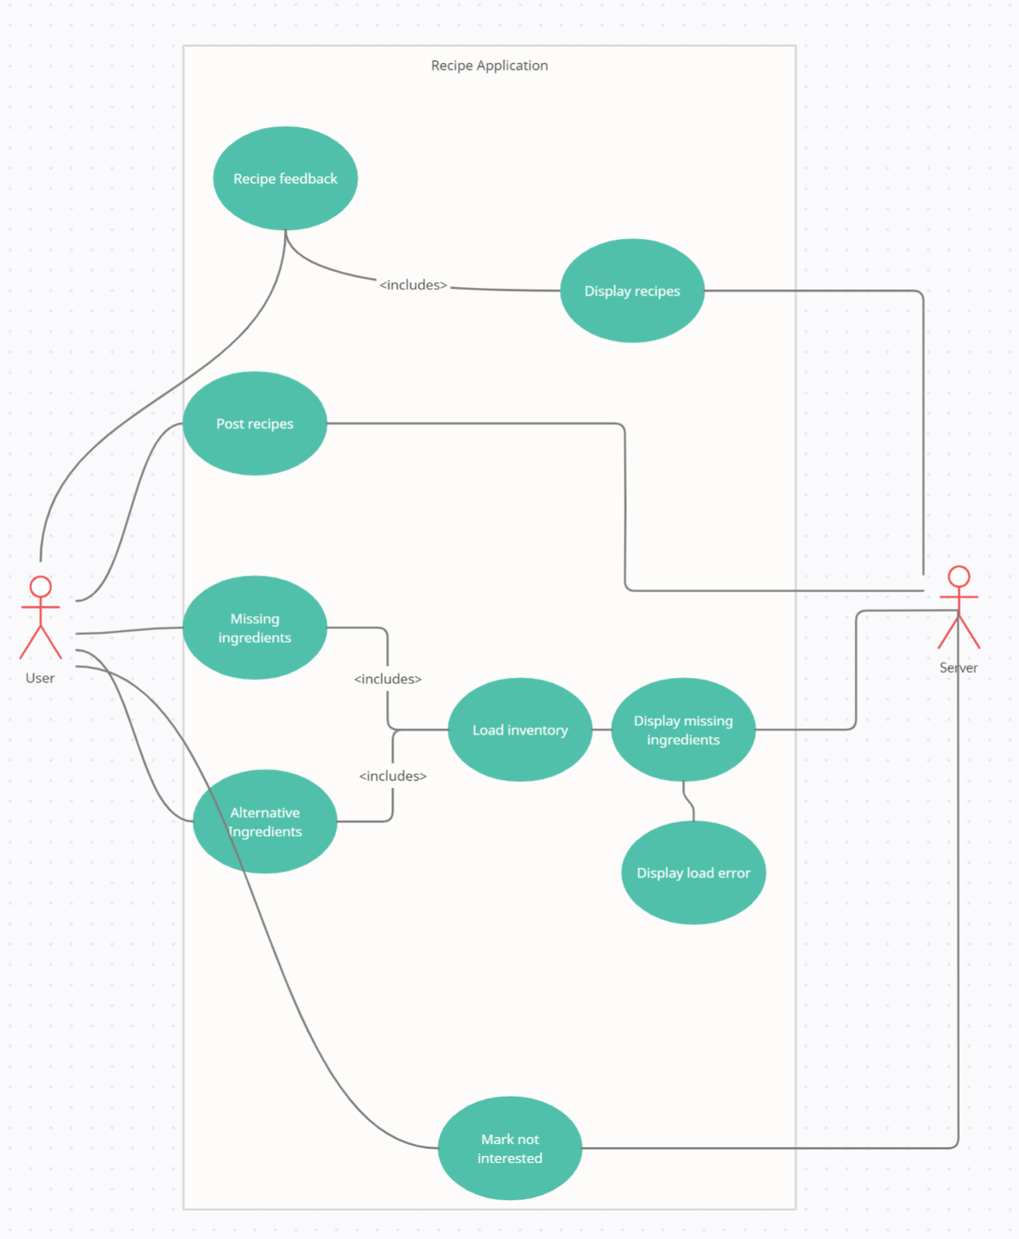

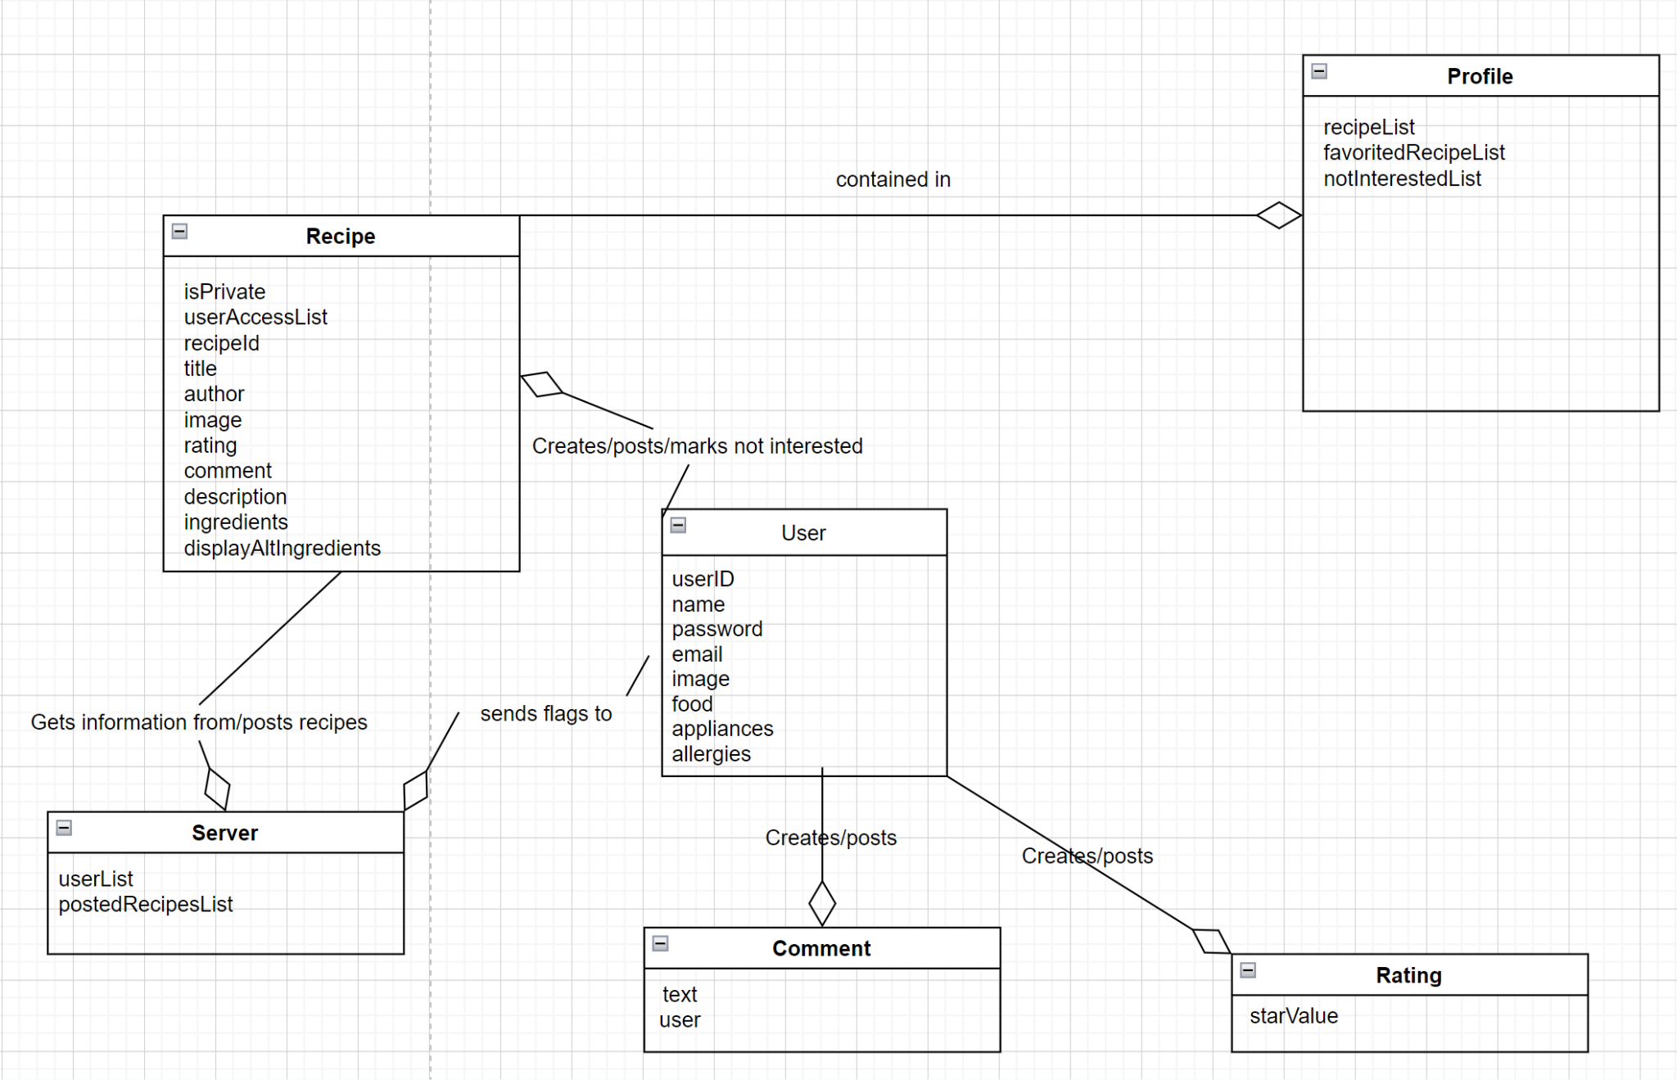

Shrenik Peddibhotla —------------------------------------------------------------------------------------------------------

Use Case 1

*Add a function to be able to automatically keep track of the calories of each meal based on ingredients used*

**Primary Actors:** User

**Stakeholders and Interests:**

The user wants to have a way to keep track of the calorie they eat

The app owner wants the user to have a good experience, so they come back to the app

**Preconditions:**

The user has logged into the app, selected at least one recipe, and the recipe has at least one ingredient with a calorie level that is known.

**Postconditions:**

The user sees the correct number of total calories of the recipes they selected at the bottom of the screen.

**Main Success Scenario:**

1. The user selects the add button on a recipe

2. System records the total sum of the calories of the ingredients present in that recipe

3. System presents the calorie sum to the user at the bottom of the screen

4a. User selects the add button on another recipe

1. System records the total sum of the ingredients of the new recipe

2. System then adds the number of calories from the new recipe to the first recipe

3. System displays this at the bottom of the screen

**Special Requirements:**

The add operation is completed and the calories are displayed within a second of the user adding a recipe

**Variations:**

App should be website-based, so technological changes shouldn’t have a major effect.

**Frequency of Occurrence:**

Common

Use Case 2

*Have a calendar section where you can manually set and plan certain recipes/meals on certain days in order for you to remember them.*

**Primary Actors:** User

**Stakeholders and Interests:**

The user wants to have a way to post recipes on days and times that they’re on the app.

The app owner wants the user to have a good experience, so they come back to the app

**Preconditions:**

The user has created at least one recipe.

**Postconditions:**

The recipe that the user created is successfully posted to their account at the date and time they specified

**Main Success Scenario:**

1. The user opens the calendar section of the app

2. The system displays a calendar with days, months, and years available starting on the current day and going up to two years from the current date

3. The user selects a specific day to add the recipe

4. The system asks the user which recipe they would like to add

5. The user selects a recipe from a drop-down menu

6. The system asks the user what time they would like the recipe to be posted

7. The user enters the time they would like to add the recipe

7a. The time is invalid

1. System rejects the time provided

2. System asks the user to enter a valid time

8. The system shows a success message and tells the user exactly when the recipe will be posted

9. On the time given, the recipe chosen is posted to the user’s account

**Special Requirements:**

The calendar posts the recipe within 60 seconds of the exact posted time by the user

The user does not have to be on the app or logged in for the recipe to automatically post

**Variations:**

App should be website-based, so technological changes shouldn’t have a major effect.

**Frequency of Occurrence:**

Occasional

Use Case 3

*Add a function that allows users to see the 100 highest rated recipes on the platform - which is ordered automatically*

**Primary Actors:** User

**Stakeholders and Interests:**

The user wants to know what the best recipes on the platform so they can try them out

The app owner wants the user to have a good experience, so they come back to the app

**Preconditions:**

There is at least one recipe posted on the platform.

At least one recipe has been reviewed on the platform.

User has logged into the app.

**Postconditions:**

A list of the highest rated recipes on the platform is displayed.

**Main Success Scenario:**

1. The user selects the sort button

2. The system opens a drop-down menu

3. The user selects “Highest Rated”

4. The system sorts every recipe on the platform based on rating

4a. Two or more recipes have the exact same rating

1. The recipe that was posted first is first, and the rest in descending order of time since posting

5. The system displays a page showing the top 10 recipes on the platform sorted in descending order of their rating

6. At the bottom of the screen, the system displays an option to go to the next page

7. The user navigates to the bottom of the screen and clicks to go to the next page

8. The system displays the 11th to 20th highest rated recipes on the platform

9. At the bottom of this page, the system displays an option to go back to the previous page

10. The user keeps clicking to the next page until they reach the 91st to 100th highest rated recipes

11. At the bottom of this page, the system displays a message indicating that this is the end of the list, and doesn’t display a “Next Page” option

**Special Requirements:**

The app displays the list of highest rated recipes within three seconds of the user selecting it

The app navigates to the next page within 1 second

**Variations:**

App should be website-based, so technological changes shouldn’t have a major effect.

**Frequency of Occurrence:**

Low

Use Case 4

Add a list of recipes that is automatically updated that contains the ten most popular recipes being looked at by other users posted over the last month.

**Primary Actors:** User

**Stakeholders and Interests:**

The user wants to know what the most popular recipes on the platform are so they can try them out

The app owner wants the user to have a good experience, so they come back to the app

**Preconditions:**

There is at least one recipe posted on the platform.

At least one recipe has been viewed by another user

User has logged into the app.

**Postconditions:**

A list of most popular recipes of a certain month is displayed

**Main Success Scenario:**

1. The user selects the sort button

2. The system opens a drop-down menu

3. The user selects “Most Popular”

4. The system sorts every recipe posted in the last month on the platform based on view count

4a. Two or more recipes have the exact same view count

1. The recipe that was posted first is first, and the rest in descending order of time since posting

5. The system displays a page showing the top 30 most viewed recipes on the platform that were posted in the last month, sorted by descending order of view count.

**Special Requirements:**

The app displays the list of most popular recipes within three seconds of the user selecting it

**Variations:**

App should be website-based, so technological changes shouldn’t have a major effect.

**Frequency of Occurrence:**

Low

Use Case 5

Add a function for people to post pictures of finished products of recipes they've made

**Primary Actors:** User

**Stakeholders and Interests:**

The user wants to be able to post pictures of recipes they’ve made

The app owner wants the user to have a good experience, so they come back to the app

**Preconditions:**

There is at least one recipe posted on the platform.

The user has prepared the recipe they want to post a picture of

**Postconditions:**

The user successfully posts a picture of the recipe they’ve made

**Main Success Scenario:**

1. The user takes a picture of the finished recipe product

2. The user logs into the app

3. The user navigates to the recipe they just made (it can be theirs or someone else’s)

4. The user selects the ‘post a picture’ option under the recipe

4a. The recipe creator doesn’t have the ‘post a picture’ option enabled

1. The system displays an error message to the user saying this creator doesn’t have this option enabled

5. The system opens up the user’s camera roll and asks it to select the picture they wish to post

5a. The system does not have access to the user’s camera roll

1. The system displays a message asking the user to enable camera roll access for the app

6. The user selects the picture

6a. The user selects multiple pictures

1. The system displays a message saying the user can only select one picture

7. The picture is posted under the ‘Pictures’ tab of that recipe

7a. The recipe creator doesn’t like the picture for any reason

1. The recipe creator navigates to the picture and selects the delete button

2. The picture is deleted from the ‘Pictures’ tab

**Special Requirements:**

The app is able to upload the picture to the platform within five seconds of the user selecting it

**Variations:**

App should be website-based, so technological changes shouldn’t have a major effect.

**Frequency of Occurrence:**

Low

Use Case Diagram:

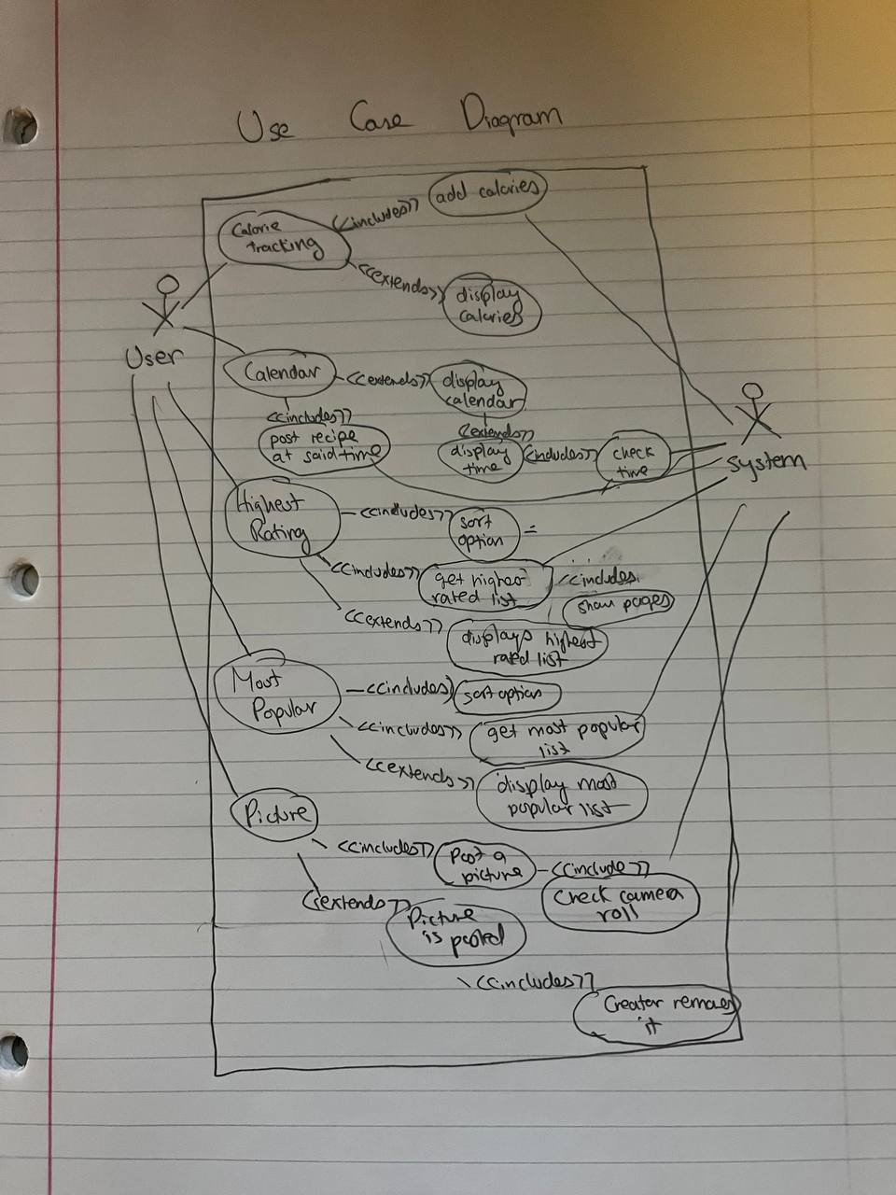

Class Diagram:

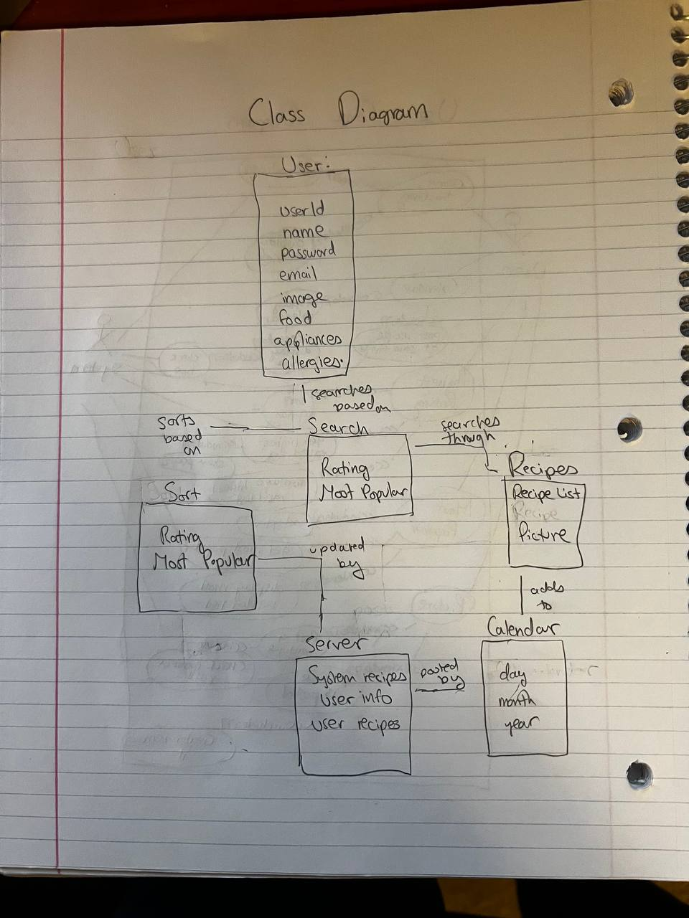

Michael Guyer—---------------------------------------------------------------------------------------------------------

| **All accounts should be secured with a password that is required upon login.** | |
| --- | --- |
| Name | Account Access |
| Primary Actor | User |
| Stakeholders and Interests | * User - wants their account to be secure * Owner - does not want security breaches for users profiles |
| Preconditions | User has already created an account with a password |
| Success Guarantee | User logs into their account safely and securely |
| Main Success Scenario | 1. User opens app and is met with a login screen 2. User enters login credentials into username and password fields 3. System checks the login credentials entered by user, to see if the account exists or the username/password is correct 4. User successfully logs into their account 5. User’s profile page is displayed |
| Extensions | 1a. User chooses to enter “Guest Mode”, instead of entering login credentials   1. Data stored on their device is loaded by the app, such as saved recipes   3a. Wrong username or password entered   1. App signals user that the wrong username or password was entered 2. App requests user to re-enter password and username   3b. User does not have an account   1. App provides user an option on the login screen to create a new account 2. User enters appropriate username, and enters appropriate password for the account twice to ensure the user has entered the desired password |
| Special Requirements | 1. Username of newly created account meets requirements 2. Password of newly created account meets requirements 3. Logging in should not take longer than 5 seconds 4. Password must be securely stored by the application |
| Variations | 2. For the application’s website, username and password should be entered via keyboard input  2. For application’s the mobile app, username and password should be entered via touchscreen keyboard input |
| Frequency of Occurrence | Somewhat often |

| **Add a function that allows users to post private recipes that can only be viewed by certain users** | |
| --- | --- |
| Name | Posting private recipes |
| Primary Actor | User |
| Stakeholders and Interests | * User - wants to allow their recipes to only be accessed by certain users * Other user - wants to access private recipes of another user |
| Preconditions | User has logged into an account, and not guest mode |
| Success Guarantee | Only specified users can access the recipe |
| Main Success Scenario | 1. User creates a recipe to post, and selects from a drop down menu to make it private, rather than public 2. System allows the user to search for other users to give access to the recipe 3. User posts the private recipe that can now be accessed by the other specified users |
| Extensions | 2a. One or more specified users to give access to the private post does not exist   1. System allows user to search for other users   2b. User gives permission to wrong user to access private post   1. User goes to permission/access settings of private post 2. User removes the mistakenly added user from the list of users with access permission 3. System saves the update permission/access settings of the private post |
| Special Requirements | * Ability to post private recipes should be a fast and intuitive process for the user * Ability to give permission to other users to view a privately posted recipe should be a fast and intuitive process |
| Variations | There should be essentially no technology or data variations involving this use case. |
| Frequency of Occurrence | Not often |

| **Add a way for users to block other users from viewing their account/messaging** | |
| --- | --- |
| Name | Block user |
| Primary Actor | User |
| Stakeholders and Interests | * User - wants to block possible harassers from viewing their account or a specific recipe * Owner - wants to ensure users are not harassed and, to a certain degree, can curate their experience on the app |
| Preconditions | User must be logged into an account, and not guest mode |
| Success Guarantee | User has removed all communication over the app with the blocked user |
| Main Success Scenario | 1. User navigates to the search bar 2. User searches for the user 3. User goes to account page of the user 4. User clicks on an icon of the other user’s account page that displays a menu of options 5. User clicks “Block user” 6. Blocked users account page is now displayed with a message saying “Blocked user” for the user |
| Extensions | 2a. The searched account does not exist with the username that was searched for   1. No results are displayed, and the system notifies the user that no accounts exist with that username   5a. User accidentally clicks on “Block user” from the menu of options   1. User clicks back on the menu of options on the other user’s account page, and clicks “unblock user” 2. User may navigate to correct account page of user they want to block |
| Special Requirements | N/A |
| Variations | There should be essentially no technology or data variations involving this use case. |
| Frequency of Occurrence | Rare |

| **Add the ability for the user to search other specific users, message them, and visit their profile page where the user can view a list of the recipes this other person has made.** | |
| --- | --- |
| Name | User search |
| Primary Actor | User |
| Stakeholders and Interests | User - wants to find other users, be able to interact with other users, and visit the account pages of other users |
| Preconditions | User must be logged into an account or on guest mode |
| Success Guarantee | User can find and visit other account pages, and message users |
| Main Success Scenario | 1. User navigates to the search tab 2. User enter the name of the user to find 3. System checks if accounts exist with that username 4. User clicks on the name of the user and is brought to the account/profile page 5. User can view the list of recipes the other user has made or favorited 6. User can click message icon on the other user’s account page to message the user |
| Extensions | 3a. Account does not exist with that username   1. No results are displayed, and the system notifies the user that no accounts exist with that username   5a. If given permission, user may view and favorite privately posted recipes of the other user’s account |
| Special Requirements | Loading the search results for other accounts/users should only take no longer than 5 seconds |
| Variations | There should be essentially no technology or data variations involving this use case. |
| Frequency of Occurrence | Fairly often |

Use Case Diagram:

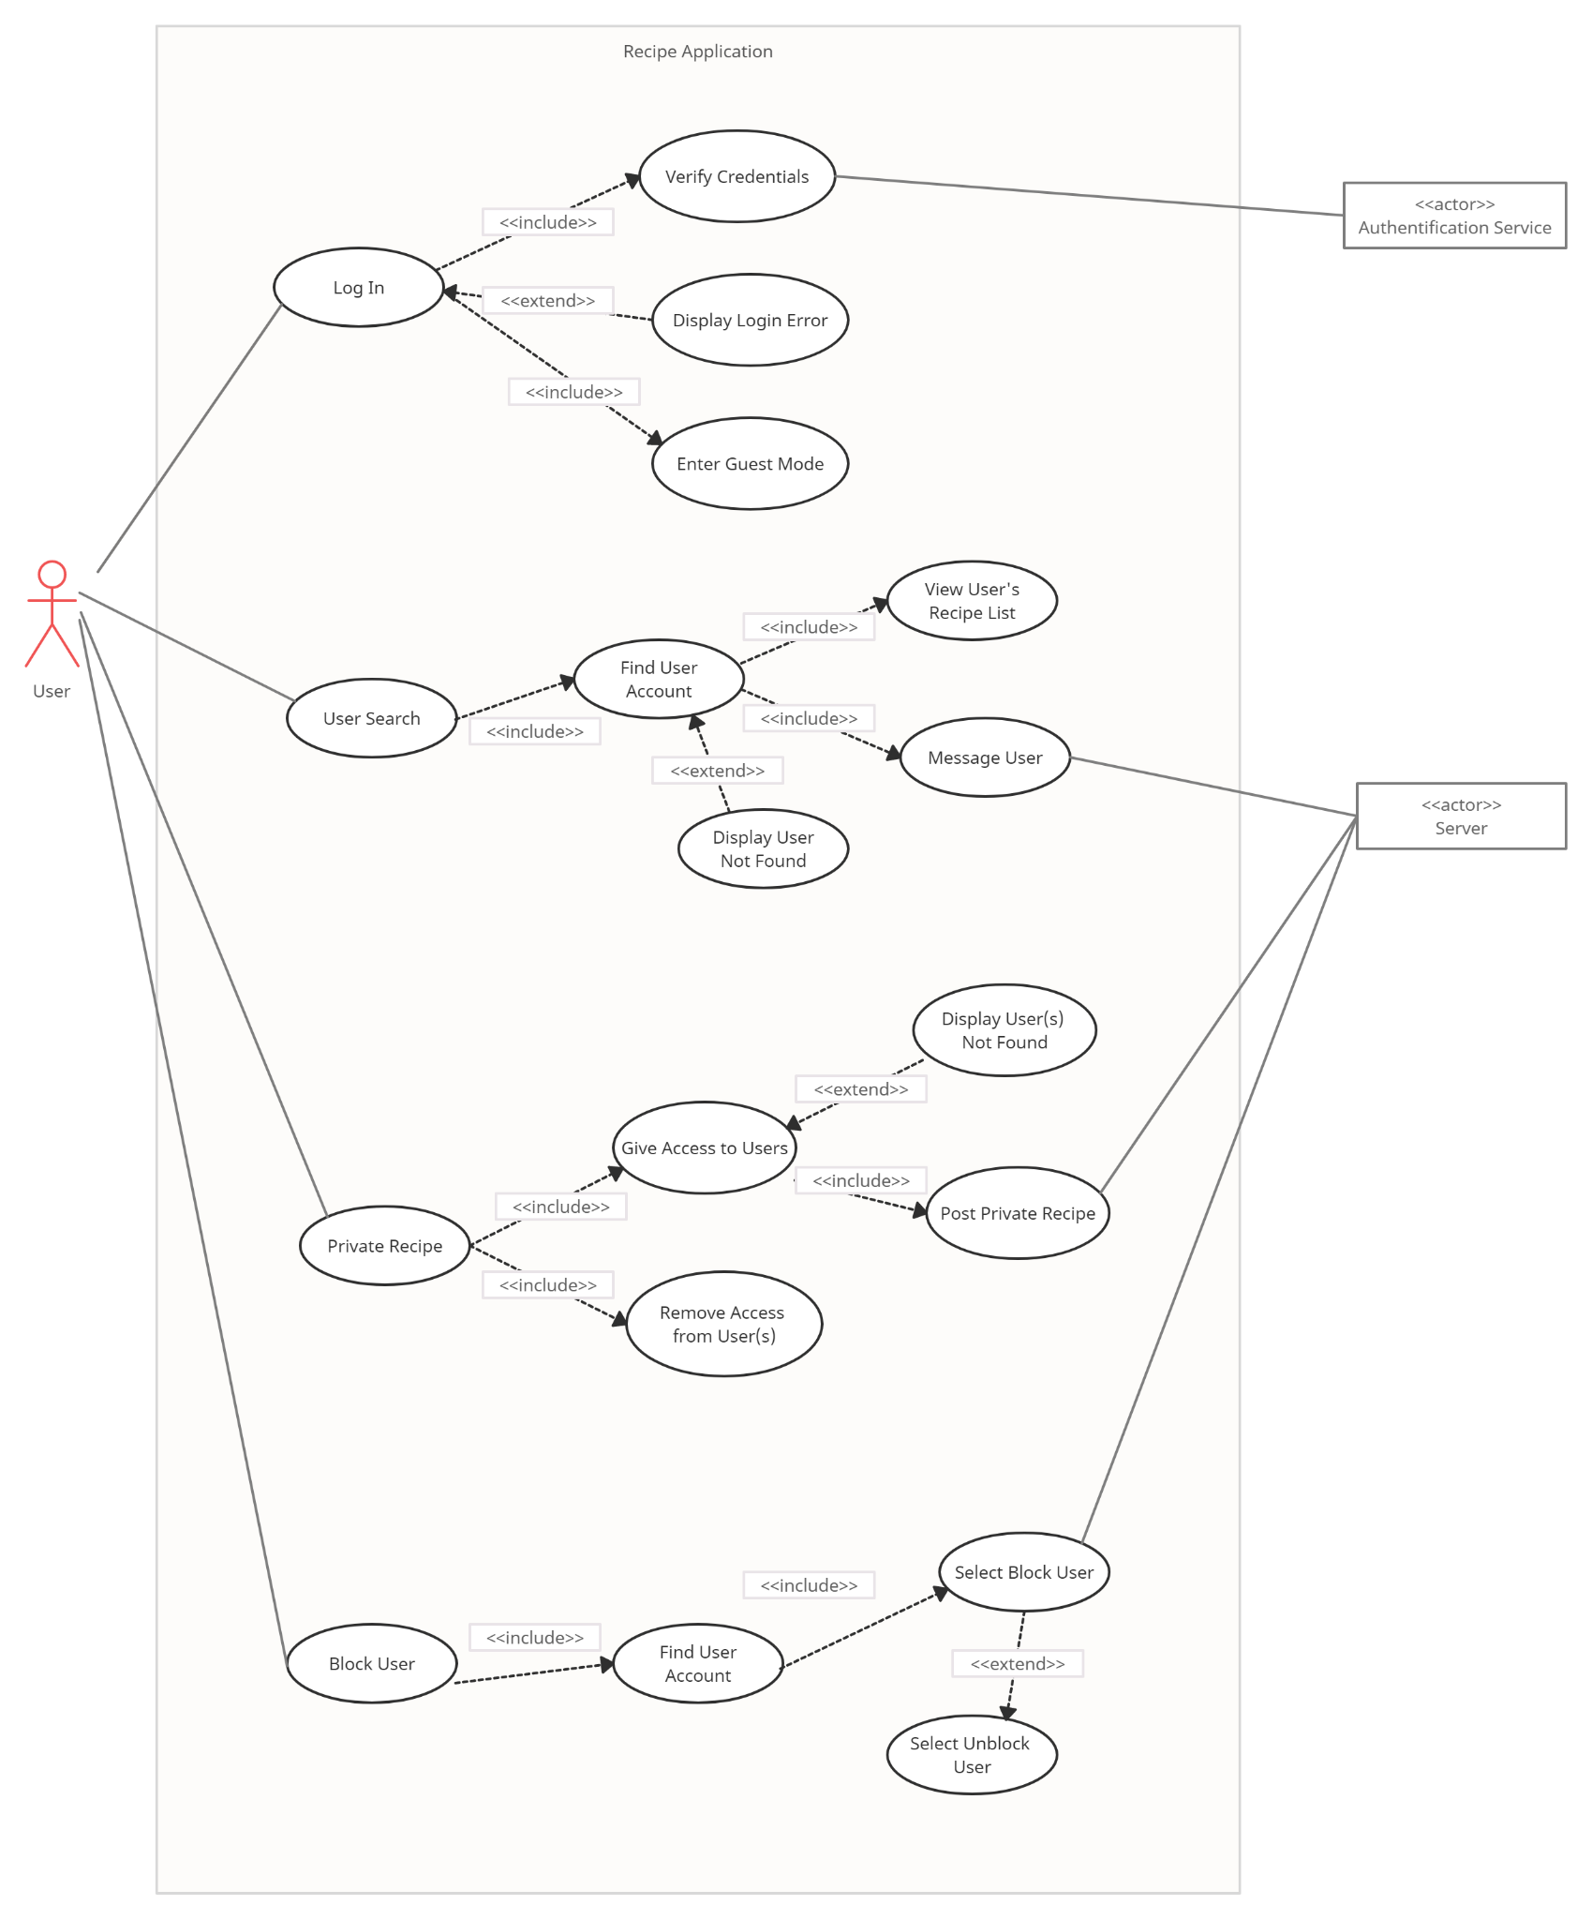

Conceptual Class Diagram:

